***BIG DATA:***

What is Big Data?

Big Data refers to extremely large datasets that are complex and grow rapidly over time. Traditional data processing tools often struggle to handle such data efficiently. Big Data is not just about size—it’s about extracting meaningful insights from vast, varied, and fast-moving information.

**The concept of the 4 V’s helps define the key characteristics of Big Data:**

| **V** | **Description** |
| --- | --- |
| **Volume** | The amount of data generated and stored |
| **Velocity** | The speed at which data is generated and processed |
| **Variety** | The different types and sources of data |
| **Veracity** | The trustworthiness and quality of data |

These dimensions help organizations understand how to manage and derive value from Big Data.

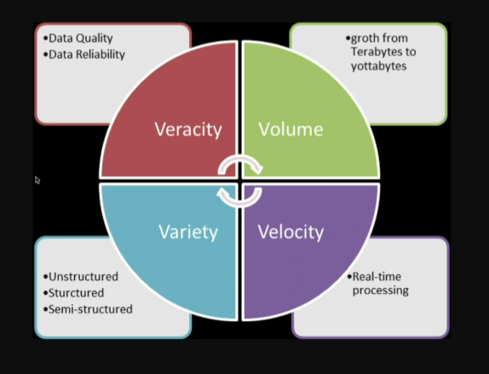

***Deep Dive into Each V:***

1️⃣ **Volume**

* Refers to the **scale of data**.
* Examples: Social media posts, sensor data, transaction logs.
* Technologies like Hadoop and cloud storage help manage massive datasets.
* Challenge: Storing and retrieving petabytes of data efficiently.

2️⃣ **Velocity**

* Indicates the **speed of data generation and processing**.
* Real-time data from IoT devices, financial markets, or live streams.
* Tools like Apache Kafka and Spark Streaming enable real-time analytics.
* Challenge: Processing data fast enough to make timely decisions.

3️⃣ **Variety**

* Represents the **diversity of data formats**.
* Structured (SQL databases), semi-structured (JSON, XML), and unstructured (videos, images, text).
* Requires flexible data models and integration tools.
* Challenge: Harmonizing data from multiple sources for analysis.

4️⃣ **Veracity**

* Concerns the **accuracy and reliability** of data.
* Data may be incomplete, inconsistent, or biased.
* Data cleansing and validation techniques are essential.
* Challenge: Ensuring data quality for trustworthy insights.

Real-World Applications and Conclusion

***🌐 Real-World Applications:***

* **Healthcare**: Analyzing patient records (Volume), wearable device data (Velocity), medical images and notes (Variety), and ensuring data accuracy (Veracity).
* **Retail**: Tracking customer behavior, inventory, and sales trends in real time.
* **Finance**: Fraud detection using high-velocity transaction data and diverse sources.

***🧠 Conclusion:***

Understanding the **4 V’s of Big Data** is crucial for designing scalable and intelligent data systems. Each V presents unique challenges and opportunities. By leveraging appropriate tools and strategies, organizations can transform raw data into actionable insights.